Materials Handling from the silo to the machine

motan-colortronic components for storage, drying, conveying, mixing, dosing and controls as well as comprehensive planning know-how lead to efficient, process-safe solutions. At the Fakuma 2018 units and modules equipped with new functions as well as revised modules will be shown.

Less wear on abrasive materials
With the coupling system METROCONNECT U / C motan-colortronic provides a high-quality manual coupling station for vacuum conveying systems. Easy to use, safe and reliable in the process, even with difficult materials, it forms a cost-effective entry into the central material supply. The customer can choose from an uncoded version and a coded version with RFID technology.
Coupling station pipe work is ususally made from robust and easy to clean stainless steel. As an alternative, we now offer specially hardened, surface-nitrated distribution branches specifically designed for conveying particularly abrasive materials such as coal or glass fibre reinforced granules. These are also suitable for problematic recycling materials.
Mixer modules for many applications
Already successfully used with the MINIBLEND V, motan-colortronic now has adapted the mixer module 2l for the volumetric MINICOLOR V and gravimetric MINICOLOR G dosing units, as well as a version for integration with third party dosing systems. Various connection, assembly and protection options enable flexible use. The unit can be installed directly under the dosing unit on the machine or it is also possible to combine it with material loaders and proportioning valves as well as small drying bins.
From materials handling to sustainable material management
motan-colortronics LINKnet 3.0 offers everything the customer expects from a state-of-the-art material management system: system utilization, user administration and recipe management. Functions, such as provision of process data and archiving for subsequent systems, generate additional benefits for our customers. The modular structure of LINKnet 3.0 allows the extension of the standard for the implementation of specific customer requirements at any time.
Alarms centrally visualized
In order to centrally display alarms in the system, motan also offers a simple, cost-effective version with the new ALARMcollector. The practical alarm box opens up new possibilities for many customers to digitally monitor their production.
In addition to the ease of use and setup of the digital display of alarms, the new ALARMcollector boasts a sleek design and user-friendly interface. The output of the alarms is possible on any Internet-enabled device and can thus anywhere, no matter whether on a laptop, tablet or smartphone, are issued!
The ALARMcollector, which can be ordered from January, can be tested directly at the motan-colortronic stand, be it on the provided tablet or directly on your own smartphone.
We are looking forward to your visit!
Fakuma 2018, Hall B1, Stand 1111

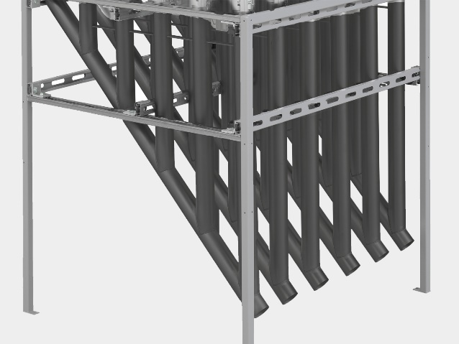
Photo 1: METROCONNECT U/C: The new surface nitrided distribution branches for particularly abrasive materials

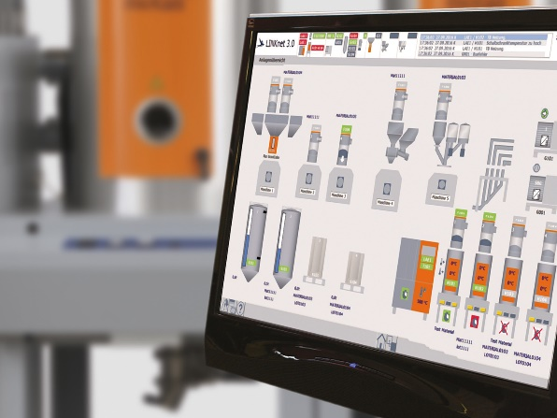 Photo 3: LINKnet 3.0 visualization on the desktop screen

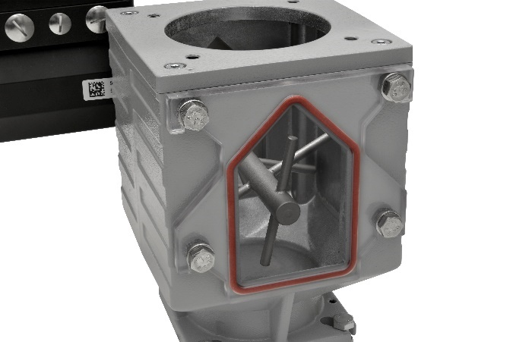
Photo 2: Mixer module 2l-MB: optional mixer for the MINIBLEND V enables homogeneous incorporation of powdered components into complex compounds.
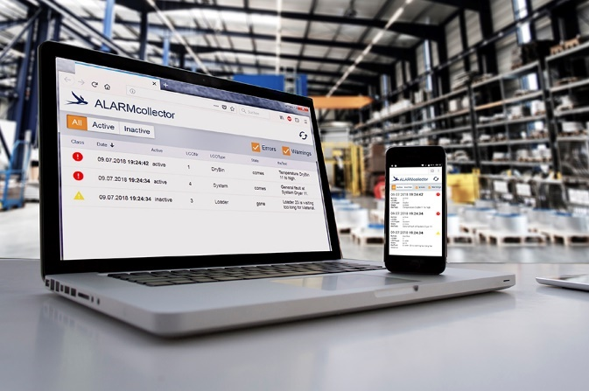Photo 4: ALARMcollector: example alarms on different devices
The motan-group
The motan group based in Constance was founded in 1947. As leading provider for sustainable raw material handling, they operate in the areas injection moulding, blow moulding, extrusion and compounding. Innovative, modular system solutions for storage, drying and crystallisation, conveying, dosing, and mixing of raw materials for the plastics manufacturing and processing industries are part of the application orientated product range. Production takes place at different production sites in Germany, India, and China. motan-colortronic distribute their products and system solutions via their regional centres. With over 500 employees currently, a yearly turnover of roughly 128 million euros is achieved. Because of their network and long-standing experience, motan can offer their customers what they really need: Individually tailored solutions with real added value.

Contact:
motan-colortronic gmbh
Rüdiger Kissinger
Otto-Hahn-Str. 14
61381 Friedrichsdorf / Deutschland

Tel. +49 6175 792-214
ruediger.kissinger@motan-colortronic.de
www.motan-colortronic.com

